Project Design Phase: Solution Architecture
Date: 19 February 2026

Team ID: LTVIP2026TMIDS62187

Project Name: Flavour Fusion: AI-Driven Recipe Blogging

Maximum Marks: 4 Marks

Architectural Strategy
The architecture for Flavour Fusion is designed to handle high-latency AI processes without degrading the user experience. By utilizing an asynchronous communication pattern between the React frontend and the Node.js backend, we ensure the UI remains responsive.

Scalability: The use of MongoDB Atlas allows the database to scale as the user's recipe library grows.

Security: A Middleware layer handles JWT Authentication and ensures the
Gemini API Key is never exposed to the client-side browser.

Efficiency: Gemini 2.5 Flash was chosen for the inference engine to provide a balance between deep culinary knowledge and rapid response times.

Solution Architecture Diagram
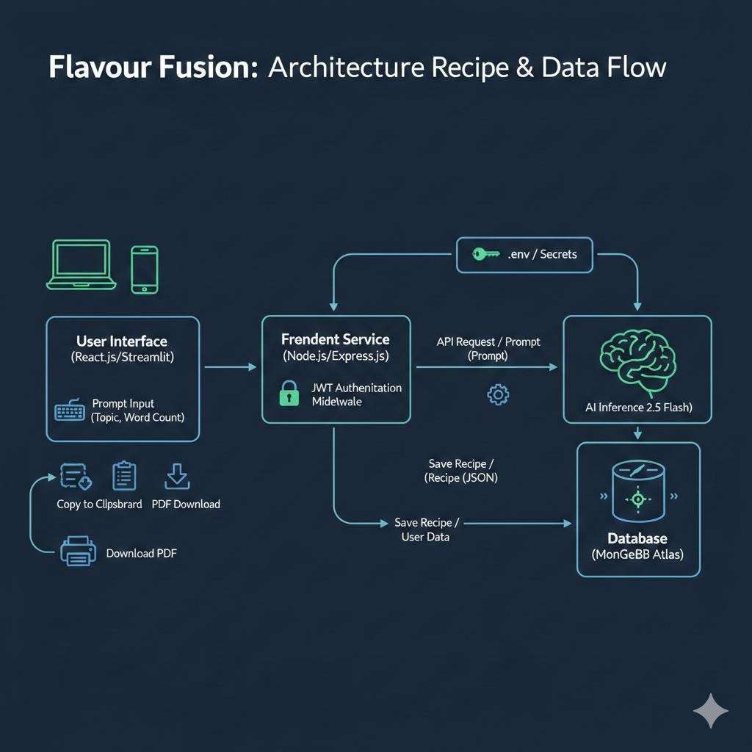
Figure 1: Architecture and Data Flow of the Flavour Fusion Application Data Flow Description:

User Input: The user enters a recipe topic and word count via the React.js
interface.

Request Handling: The frontend sends a POST request with a JWT token to the Express.js backend.

Security & Env: The backend retrieves the Google API Key from the .env file (protected environment).

AI Inference: The server communicates with the Gemini 2.5 Flash model, sending a structured prompt.

Data Processing: The AI returns raw text; the Node.js server formats this and sends it back to the client.

Persistence: Optionally, the generated recipe and metadata are stored in
MongoDB for the user's dashboard.

Export: The user can trigger a client-side function to convert the JSON response into a PDF using the FPDF/jspdf library.

Solution Specifications

Component | Technology | Role
Frontend | React.js / Streamlit | Manages the UI, user input, and PDF export rendering.
Backend | Node.js & Express | Handles routing, authentication, and AI API orchestration.
Database | MongoDB | Stores user profiles, saved recipes, and session data.
AI Model | Gemini 2.5 Flash | Acts as the "Brain" for creative recipe writing and formatting.
Security | .env / JWT | Ensures credential safety and authorized access to the AI engine.

- Stakeholder Value
For Users: Provides a fast, reliable, and secure way to generate content.

For Developers: Follows a modular MERN structure, making it easy to add future features like "Image Generation" or "Social Media Auto-posting."

